Linux Operating system
- Linux is a multi-user Logging to same operating system at the same time.
- Open-Source Operating system.
- Linux works on CLI (Command Line Interface).
- Linux is more secure in compare to Windows
- Linux different flavours (Ubuntu, RHEL, Amazon Linux, CentOS, SUSE).
- Commands will be same for all the Linux, packages may vary.
Ubuntu - is one of the Operating System based upon Linux distribution.
Virtual box – For Multiple Applications deployment in the single machine. So, we can Segregate between different operating System. It is also called as Virtual desktop.
Git bash- Is also Kind of software help us to execute basic Linux command.
Containerization – IT is a latest technology which will help you to create container meaning Light weight Virtual machine.
Kerner – Consist of pre- defined programmes it is also known as heart of operating system.
Shell – is a programme which takes input & gives output.
Terminal – is a tool to execute the shell command.
/ Root – parent directory
~(Tild) – Home directory.
Few Sample Commands executed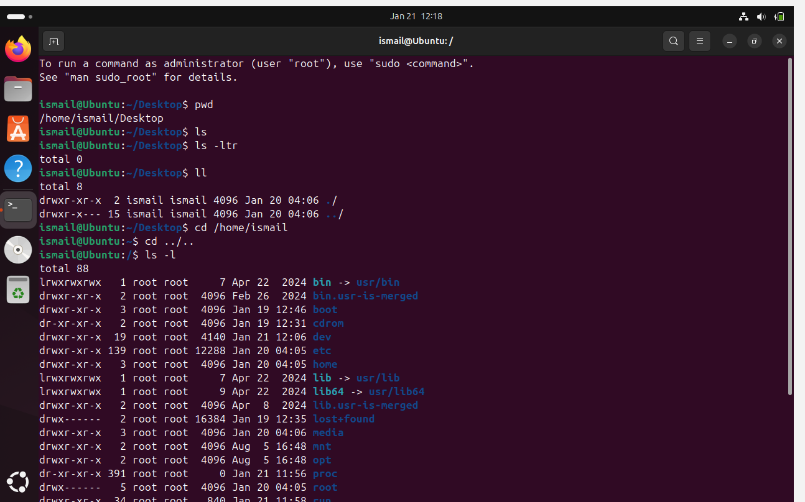
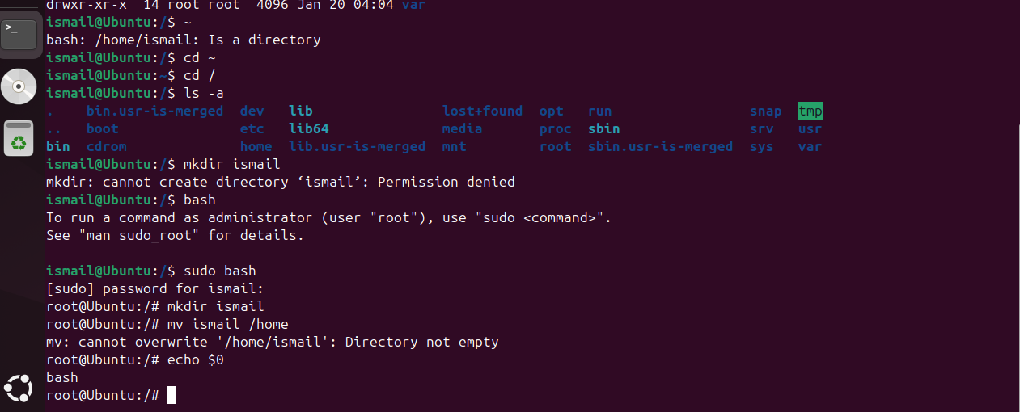
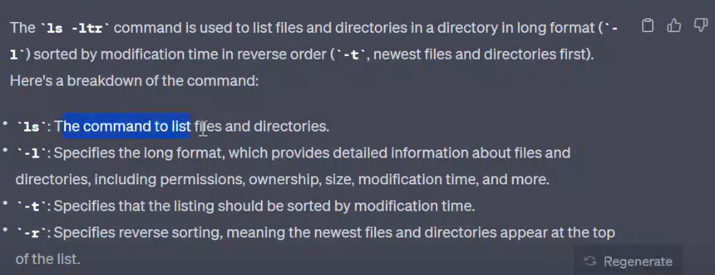
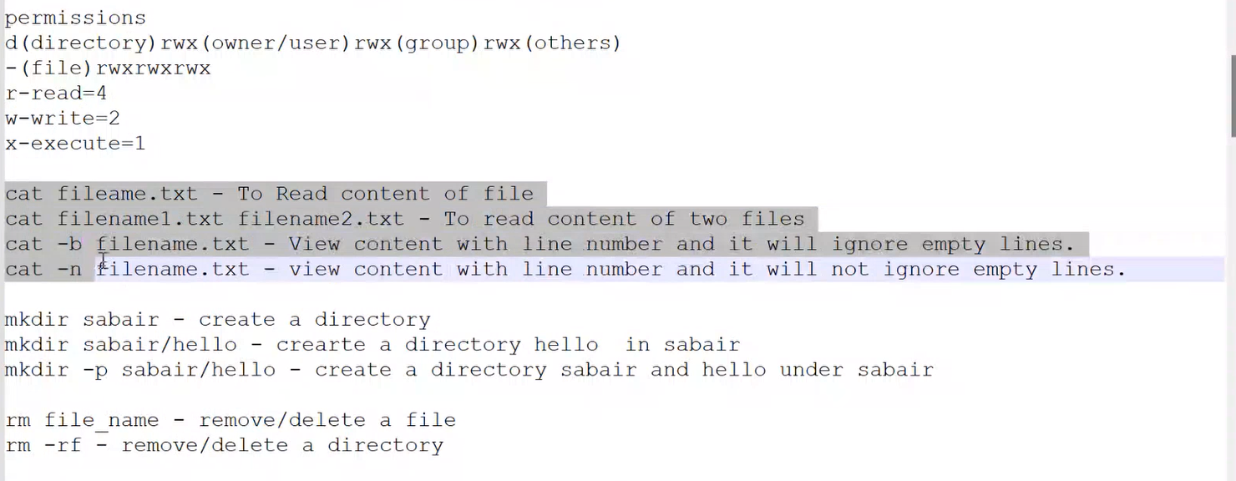

Editor in Linux
